CRITIC (n)

A person who expresses an unfavorable opinion of something or judges something

Example:

The critic was unimpressed by the dancer’s performance.

If a person were a critic for something, would they:
- Appreciate it
- Judge it
- Ignore it
- Voice their opinion of it

---------------------------------------------------------------------------------------

MILLIMETER (n)

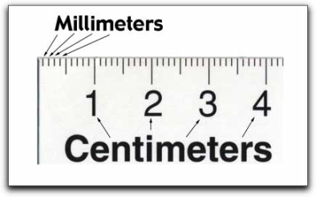
One-thousandth (1/1000) of a meter.

Example:

The thickness of a credit card is about 1 millimeter.

Which of the following items would you measure using millimeters?
- Thickness of a penny
- The height of a child
- The length of a finger nail
- The length of a dog
- The thickness of a sheet of paper

