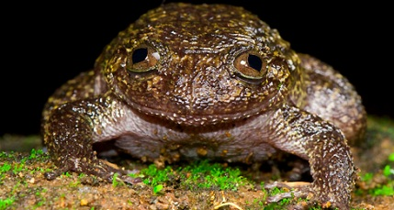
Name: ___________________________
Fascinating New Frogs

Learning Targets:
I know what common affixes and roots mean.
I can use affixes and roots to help to figure out words.
I can figure out the meaning of a word using context clues.
I can make sure my guesses about a words meaning are correct by looking them up in a dictionary.

Directions: Read the article “Fascinating New Frogs” and determine the meaning of the words listed in the chart. Be sure to create a definition of the word and explain how you figure it out.

WORD | MEANING | EXPLANATION
Existence | State of actually being real | Exist: to have actual being, to be real  -ence: act, fact, quality, or state
Genetics |  | Gene: heredity or traits you get from other family members  -ics means relating to the science of
Rediscovered |  | Re-:  Discover:  ed: past tense
Scientists |  | Science: Knowledge gained through experiments about the world around us  ists:
WORD | MEANING | EXPLANATION
Biological |  | Bio:  ology:  Ic: having characteristics of  al: related to
Intrepid |  | In:  Trepid: timid
Exposure |  | Ex: Out  Pose: to place  ure: the act of, use, or practice
Indicators |  | Indicate: point out  ors:
Pollutants
Threatened

What words did you notice in the reading that belonged to the word family “discover?”
____________________________________________________________________________________

