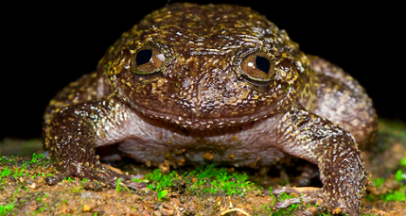
Name: ________KEY________________
Fascinating New Frogs

Learning Targets:
I know what common affixes and roots mean.
I can use affixes and roots to help to figure out words.
I can figure out the meaning of a word using context clues.
I can make sure my guesses about a words meaning are correct by looking them up in a dictionary.

Directions: Read the article “Fascinating New Frogs” and determine the meaning of the words listed in the chart. Be sure to create a definition of the word and explain how you figure it out.

WORD | MEANING | EXPLANATION
Existence | State of actually being real | Exist: to have actual being, to be real  -ence: act, fact, quality, or state
Genetics | The science of heredity/traits | Gene: heredity or traits you get from other family members  -ics means relating to the science of
Rediscovered | To notice something in the past for the first time again | Re-: again (perhaps it was forgotten)  Discover: notice something for the first time  ed: past tense
Scientists | People who study science, the things around us through experiments | Science: Knowledge gained through experiments about the world around us  ists: people who study
WORD | MEANING | EXPLANATION
Biological | Having characteristics of or being related to biology or life and living things | Bio: life  Logy: study of  Ic: having characteristics of  al: related to
Intrepid | Not timid | In: not  Trepid: timid
Exposure | The act of placing something out | Ex: Out  Pose: to place  ure: the act of, use, or practice
Indicators | Many who point out or things that point out | Indicate: point out  Or: one who  S: plural
Pollutants | Many things that act to make something harmful or unfit for living things. | Pollute: to make harmful or unfit for living things  ant:one who acts  s: plural
Threatened | To have made something in danger or harm | Threat: an indication of immediate danger or harm  en: make  ed: past tense

What words did you notice in the reading that belonged to the word family “discover?”
__discover, discoveries, rediscovered, discovering__________________________________________

