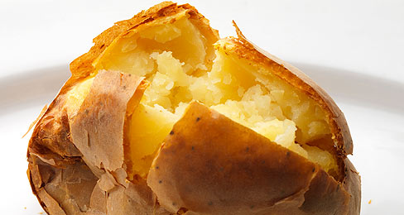
Name: _________KEY_______________
Hot Potato Issue

Learning Targets:
I know what common affixes and roots mean.
I can use affixes and roots to help to figure out words.
I can figure out the meaning of a word using context clues.
I can make sure my guesses about a words meaning are correct by looking them up in a dictionary.

Directions: Read the article “Hot Potato Issue” and determine the meaning of the words listed in the chart. Be sure to create a definition of the word and explain how you figure it out.

WORD | MEANING | EXPLANATION
Starchy | Describes something high in carbohydrates, like potatoes | Try using context clues:  Further in paragraph  “And those starchy veggies that are high in carbohydrates would also…”
Amending | changing | Try using context clues:  After comma in sentence
Imposed | To present a difficulty on something/someone | Lower in the paragraph it says “on” schools  pose: present a difficulty  ed: past tense
Encouraged | To have given support | en: to put or to give  courage: support, confidence  ed: past tense
WORD | MEANING | EXPLANATION
Proposed | Having presented a favored problem in the past | pro: favoring  pose: present a problem, danger, or difficulty  ed: past tense
Unfairly | In a way that is not according to rules | Un: not  fair: according to rules  ly: in a way or manner
Amendment | Result of change | amend: change (from earlier context clue)  ment: condition or result
Flexibility | Capable of being able to bend | flexible: able to bend  ity: capable of
Affordable | Able to manage something due to financial means | afford: to manage due to financial means  able: capable of

What words did you notice in the reading that belonged to a word family?
1. Imposed, proposal, proposed 2. criticized, critic 3. amending, amendment

2. Look back in the paragraph under the subheading “Food Fight.” Use context clues to try to decide what the word “restriction” means and then look it up in a dictionary and record the actual definition here.
The state of being kept in within certain limits

