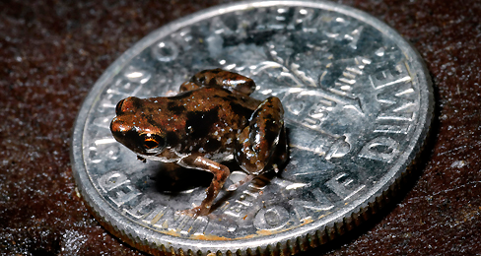
Name: __________________________
World’s Smallest Frog

Learning Targets:
I know what common affixes and roots mean.
I can use affixes and roots to help to figure out words.
I can figure out the meaning of a word using context clues.
I can make sure my guesses about a words meaning are correct by looking them up in a dictionary.

Directions: Read the article “World’s Smallest Frog” and determine the meaning of the words listed in the chart. Be sure to create a definition of the word and explain how you figure it out.

WORD | MEANING | EXPLANATION
Vertebrate

Herpetologist
Researchers

Enlarge

WORD | MEANING | EXPLANATION
Unknown

Ichthyologist

comparison

Invading

1. Look back in the last paragraph. Use context clues to try to decide what the word “niche” means and then look it up in a dictionary and record the actual definition here. If there is more than one definition, try to pick the one that seems to relate to the article.

2. Look back in the last paragraph. It mentions “litter,” but it doesn’t mean pollution. What do you think it means here?
Definition:
How did you know:

