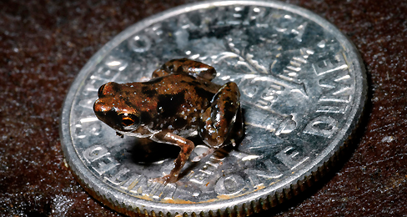
Name: ________KEY_______________
World’s Smallest Frog

Learning Targets:
I know what common affixes and roots mean.
I can use affixes and roots to help to figure out words.
I can figure out the meaning of a word using context clues.
I can make sure my guesses about a words meaning are correct by looking them up in a dictionary.

Directions: Read the article “World’s Smallest Frog” and determine the meaning of the words listed in the chart. Be sure to create a definition of the word and explain how you figure it out.

WORD | MEANING | EXPLANATION
Vertebrate | Animal with a backbone | Definition follows comma
Herpetologist | Someone who studies amphibians | Later in the paragraph
Researchers | People who collect data | research: way of collecting data  er: people who  s: plural
Enlarge | To make bigger in size | En: make  Large: big, as in size
WORD | MEANING | EXPLANATION
Unknown | Not familiar | Un – not  Known – recognized or familiar
Ichthyologist | A scientist who studies fish | After the word in the text
comparison | The act of examining similarity and differences | compare: to examine for similarities and difference  ison: the act of
Invading | Moving into | “invading this open niche of wet leaf litter that is full…”

1. Look back in the last paragraph. Use context clues to try to decide what the word “niche” means and then look it up in a dictionary and record the actual definition here. If there is more than one definition, try to pick the one that seems to relate to the article.
a. The function or position of an organism or population within an ecological community. OR
b. The particular area within a habitat occupied by an organism.

2. Look back in the last paragraph. It mentions “litter,” but it doesn’t mean pollution. What do you think it means here?
Definition: collection of leaves that are dropped by trees, small seeds, etc.
How did you know: Leaf is in front of the word, and it’s on the forest floor. Also description of scientists picking up a handful of it.

